McLaren Publishing Co.


Specializing in Puzzle Booklets
18145 Amberly Ln. * South Bend, IN 46637
(574) 521-5167 * mclarenpublishing@yahoo.com

Attention Advertisers:
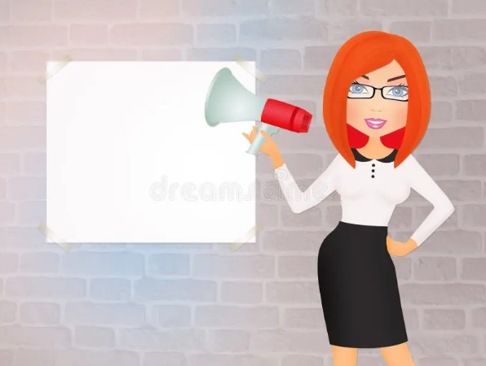
Proximity Advertising:

+ Proximity Advertising

+ Advertising Value

+ Low Customer Acquisition Cost
Booklets are distributed to desig- nated area waiting rooms with a high concentration of businesses.

Advertisers are paired with these areas for maximum ad effective- ness.

Advertising Value:
All advertisers are never more than two miles from their companion waiting rooms.

Booklets are printed and distributed in quantities of 1000 per issue. Waiting rooms gen- erally have dozens of people each and every day. Booklets have a shelf life of about 30 days. This means your ad could get viewed 1000’s of times by your most relevant target audience. Booklets have 15 pages of puzzles, producing 35 individual puzzles. There are as few as 15 advertisers per booklet. Each ad is paired with a puzzle page for maximum viewing potential. So you are literally guaranteed ad exposure.

Low Customer Acquisition Cost:
Full page ads are very inexpensive at $500.00 each. 1000’s of views means that the cus- tomer acquisition investment is just pennies per view. Alternate advertising mediums could be billboards, which cost thousands of dollars, and you never quite know if they are work- ing. Another popular advertising medium is the direct mailer, in which the cost of printing and postage could be as high as $2.00 per household, and you still don’t know if they were totally effective.

Full page* Half page** Gatefold*** Pricing: $500.00 $300.00 $800.00 Dimension: 4.5” x 7.5” 3.5” x 4.5” 4.5” x 7.5” x 2


* Ask about Word Search themes for Advertisers.
** Half page ads are available on a limited basis.
*** Gatefold ads are first come first serve.

- 10% discount for multiple ads and multiple issues.
- Ad builds are available FREE of charge.
- Booklets are printed in quantities of 1000.
- Waiting rooms are in proximity to advertisers. Advertising space is limited so reserve your spot now.
All puzzles are original, and are carefully selected for each
issue by our amazing staff.

Puzzle booklets are published monthly, are available while quantities last, are always FREE, and available upon request.

Rachal Chapman
Modern Beauty Today @ Salon Studio Suites 4125 Grape Rd. Mishawaka, IN 46545
Phone: 260 797-3010
rachapman97@gmail.com
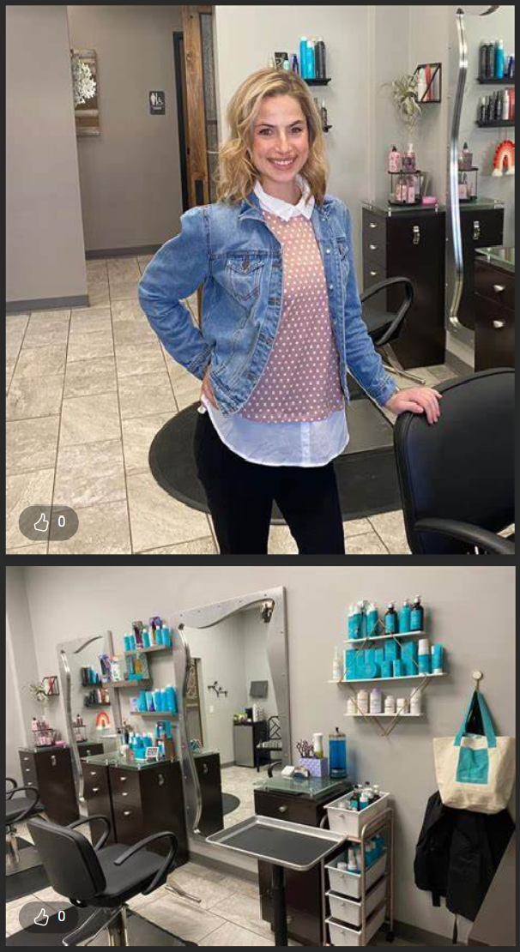
Hours: Mon Closed * Tue 10am-6pm * Wed 10am-6pm Thu 10am-6pm * Fri 9am-6pm * Sat 9am-3pm * Sun Closed
Services
Simple wax Scalp treatment Ombre
Makeup
Heat tool styling Color correction Bridesmaid hair
Bridal hair wedding day Bang trim
Airbrush makeup Air touch highlights Shaved design
New growth touch up Partial root touch up Partial highlight & gloss Partial balayage & gloss Mini highlight & gloss Medium haircut
Bridal makeup Long haircut Lip wax
Lip and brow wax Lashes
Kid’s haircut Hair consultation Gloss treatment
Full highlight & gloss Formal Style
Double process color Deep conditioning treat. Brow wax
Brow color Braids Beard trim
Balayage & gloss Short haircut
Scalp cleansing with blowout
Add on color

ADS ARE ALWAYSON THE LEFT
<===

PUZZLES AREALWAYS ON THE RIGHT
===>

GATEFOLD ADALWAYS HASTWO FACING ADSINTHE BOOKLET CENTER

Fill - In Word Fun
Cat Got Your Tongue
CATALINA Pontiac car model


CAT Stimulus, incitement
CAT Projectile mechanism
CAT Eye lens clouding
CAT Disaster CAT Enviable seat


CAT Classification
CAT Butterfly precursor CAT Cajun cuisine favorite


CAT Light sleep
CAT Feline herb
CAT Ketchup
CAT Marsh plant
CAT Super-model runway
CAT Batman villain

